CONDITON MONITORING DOCUMENT

**VELOCITY SEVRITY DETAILS**

1. 1 and 2

* First step is to install Vsens to the motor & next once Vsens is installed the next step is to configure vegam gateway to the vsens & vegam IOT platform

1. 3

The user information related to sensor specification, motor details, bearing details are taken through API.

* Details such as MAC ID of the sensor, sensor position, working mode (continous /burst/ continuous-burst mode), number of samples.
* motor details such as power of motor, sampling frequency, operating Rpm, maximum Rpm, framesize are taken from user.

1. 4

* Velocity vibration standards are mentioned & defined according to the class, using these details as ISO STANDARD table is created and stored in Mysql DB.

1. 5

* Next step is to subscribe the required Vsense topic through mqtt server, mqtt is a protocol where we can subscribe & receive the message as a client.
* MQTT (MQ Telemetry Transport or Message Queuing Telemetry Transport) is a lightweight, [publish-subscribe](https://en.wikipedia.org/wiki/Publish%E2%80%93subscribe_pattern) network [protocol](https://en.wikipedia.org/wiki/Communication_protocol) that transports messages between devices. The protocol usually runs over [TCP/IP](https://en.wikipedia.org/wiki/TCP/IP). Once the connection is established the client can send data to the broker, and the broker can send data to the client as required. You can consider a TCP/IP connection to be similar to a telephone connection. Once a telephone connection is established you can talk over it until one party hangs up.
* MQTT client connects to an MQTT broker via MQTT protocol and publishes sensor readings.
* A message has a topic and a payload, like the subject and the content of an

e-mail.

* The Publisher sends a message to the network.
* The Subscriber listens for messages with a particular topic.
* The Broker is responsible for coordinating the communication between publishers and subscribers.

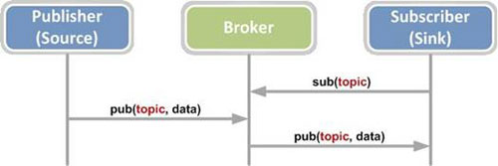

* Velocity vibration standard is classified based on the class of motor.
* For the given sensor mac id using power &maximum Rpm from the INPUT lookup table the class of motor is defined.

1. 6

Determine the class of the motor as follows

ISO 2372 (10816) Standards provide guidance for evaluating vibration severity in machines operating in the 10 to 200 Hz (600 to 12,000 RPM) frequency range. Examples of these types of machines are small, direct-coupled, electric motors and pumps, production motors, medium motors, generators, steam and gas turbines, turbo-compressors, turbo-pumps and fans. Some of these machines can be coupled rigidly or flexibly, or connected through gears. The axis of the rotating shaft may be horizontal, vertical or inclined at any angle. Use the chart below combined with additional factors described in this manual to judge the overall vibration severity of your equipment.

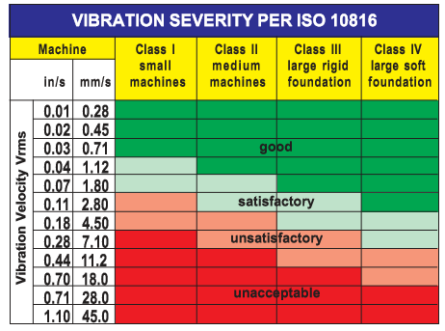

Machinery class designations are:

Class l: Individual parts of engines and machines, integrally connected with the complete machine in its normal operating condition. (Production electrical motors of up to 20 HP (15 kW) are typical examples of machines in this category.)

Class ll: Medium-sized machines typically, electric motors with 20 to 75 HP (15-75 kW) without special foundations, rigidly mounted engines, or machines on special foundations up to 400 HP (300 kW).

Class lll: Large prime movers and other large machines with rotating masses mounted on rigid and heavy foundations which are relatively stiff in the direction of vibration measurement.

Class lV: Large prime movers and other large machines with rotating masses mounted on foundations which are relatively soft in the direction of vibration measurement (for example, turbo-generator sets, especially those with lightweight ub-structures)

|  |  |  |  |  |  |  |  |  |
| --- | --- | --- | --- | --- | --- | --- | --- | --- |
|  |  |  |  |  |  |  |  |  |
|  | **P in KW** | **class1** | **class2** |  | **class3** |  | **class4** |  |
|  |  | <15KW | 15KW-75KW | | >75KW-<10MW | | >10MW |  |
|  | for rigid mounting |  | 15kW-300KW | |  |  |  |  |

1. 7

* Once the class of motor is known then the is to subscribe the required Velocity topic through mqtt server
* The required velocity tag is selected based on the sensor position

|  |  |
| --- | --- |
| position |  |
| Horizontal | Take radial vertical axis data for calculation |
| Vertical | Take radial horizontal axis data for calculation |
| Over hung | Take radial vertical axis data for calculation |

1. 8

* For each window we will receive a velocity through message call back using MQTT

1. 9

* All data will be in merged format, then we use some processing steps to clean the data and convert it to the required format.

1. 10

* next step is to find the number of velocity values for averaging.
* Number of velocity values = number of samples/windowsize
* The details required for calculation are taken from sensor lookup table stored in mysql DB

1. 11

* average the velocity values with respect to the Number of velocity values, depending on the class of motor calculated in step 5. averaged value is compared with the above iso standard lookup table mentioned in step 5, to determine level of velocity.

1. 12

* If velocity obtained lies in good range then assign 1
* If velocity obtained lies in satisfactory range then assign 2
* If velocity obtained lies in unsatisfactory range then assign 3
* If velocity obtained lies in unacceptable range then assign4

1. 13

* The velocity level is published to some topic “xyz” to publish it in Vmaint, in Vmaint side once the topic is subscribed then the results are published.

**MISALIGNMENT AND UNBALANCE DETAILS**

**UNBALANCE DETAILS**

1. 14

* If velocity level ranges in between unsatisfactory and unacceptable according to ISO standard as mentioned in step 12

1. 16 and 17

* Subscribe and read the required Radial and axial FFT tags through MQTT server

1. 18

* All data will be in merged format, then we use some processing steps to clean the data and convert it to the required format.

1. 26 and 31

* check FFT data, whether it has higher amplitude more than rms value in Axial axis and radial axis at 1x, if there is a peak then follow the following step else directly, we can conclude that there is no unbalance in the machine.
* Check for 1x amplitude peak within range 0.8x to 1.2x in Radial and Axial directions. If found check for multiple harmonics corresponding to 1x in Radial and Axial directions like 2x, 3x and 4x. if multiple harmonics not found then fault is Unbalance.

Radial FFT Block:

* If there is large amplitude peak greater then rms at 1x in the horizontal and vertical directions compared to Axial direction this is due to Unbalance.
* If there is no 1x peak greater than rms found in Radial directions, check for same 1x amplitude peak in Axial direction. If 1x amplitude peak found in Axial direction, publish Unbalance result to MQTT.

Axial FFT Block:

* If there is large amplitude peak greater than rms at 1x in the Axial direction compared to Horizontal and Vertical direction then Unbalance is suspected, and the results are published to some topic “vgh” through mqtt.

1. 27

* Subscribe to Radial and Vertical Accelerometer UUIDs through mqtt.

1. Shaft position: Horizontal.

High 1x peak at Horizontal compared to Axial.

Velocity Severity in Horizontal axes: Unsatisfactory – Unacceptable Level

Then Unbalance

Shaft position: Overhung Horizontal Shaft.

High 1x peak at Horizontal and Axial directions.

Velocity Severity: Unsatisfactory – Unacceptable Level in Horizontal and Axial directions.

On an overhung machine, imbalance and misalignment may display similar characteristics. Use phase measurements to differentiate between the two.

Shaft position: Vertical Shaft.

High 1x peak in Horizontal and Vertical directions.

Velocity Severity: Unsatisfactory – Unacceptable Level in Horizontal direction.

Then Unbalance.

1. 28

Calculate Phase angle of Radial and Vertical UUID.

* Phase analysis
* **What is Phase?**  
  Phase is the position of a rotating part at any instant with respect to a fixed point. Phase gives us the vibration direction. Tuning a car engine using a timing light and inductive sensor is an application of phase analysis.

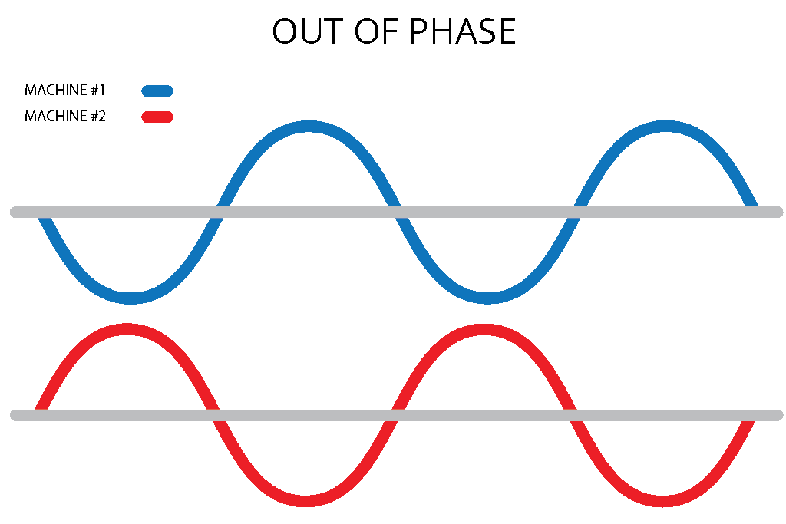

In **Figure 1**, the sine waves (vibrations) of Machines A and B do not reach their positive peaks at the same time (i.e., when Machine A reaches the top of the peak, Machine B is at the bottom). This is an indication that they are “out of phase.”

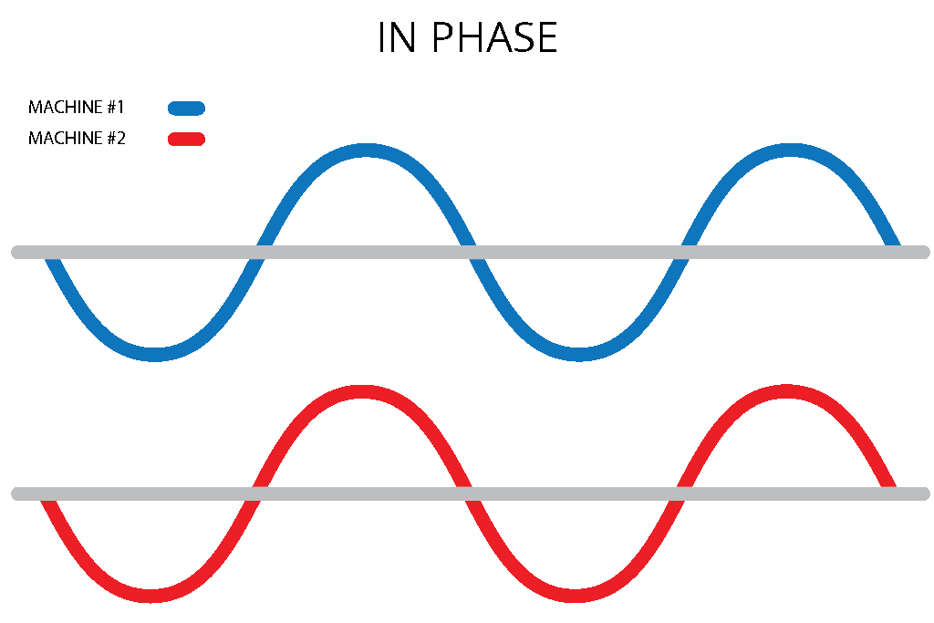

In **Figure 2**, the sine waves (vibrations) of Machines A and B reach their positive peaks at the same time – an indication that they are “in phase.”

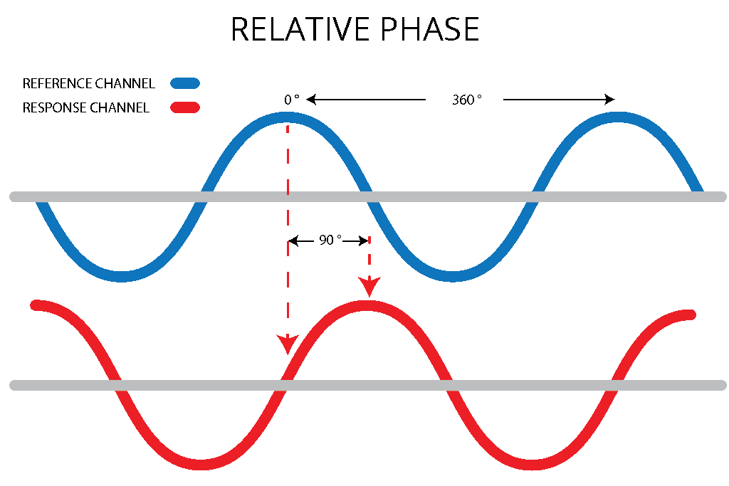

**(Figure 4)**. Relative phase does not require a tachometer so phase can be measured at any frequency. Often times, absolute phase is not necessary because many diagnoses, such as identifying loose foot or soft foot, are made by analyzing relative phase.

1. 28

* If Phase angle is within range of 60 to 120 degrees then Unbalance may be suspected

1. 29

* publish Unbalance result through MQTT to some topic.

**MISALIGNMENT**

1. 19

* subscribe the Axial and Radial FFT data through MQTT.

1. 23

* **Axial FFT Block**
* Considering axial data for motor position Horizontal, Vertical and Overhung-Horizontal)
* IF amplitude at 1 X RPM or 2 X RPM is greater than rms.
* When the vibration amplitude at 2 X RPM is 50% to 150% of 1 X RPM, it is probable that Coupling damage will occur.
* When 2 X RPM is above 150% of the 1 X RPM has severe misalignment (the problem should be Fixed as soon as possible)
* Check 3 X RPM to 8 X RPM harmonic frequency. (Amplitude difference between each harmonic is 15%)
* A phase shift of 180 degrees in the axial direction will exist across the coupling. (considering 2 sensors)

1. 24

* Publish the result as Angular misalignment

1. 33

* **Radial (Vertical) FFT Block**
* Considering Radial (Vertical) data for motor position Horizontal, Vertical and Overhung-Horizontal)
* IF amplitude at 1 X RPM or 2 X RPM is greater than rms
* When the vibration amplitude at 2 X RPM is 50% to 150% of 1 X RPM, it is probable that coupling damage will occur.
* When 2 X RPM is above 150% of the 1 X RPM has severe misalignment (the problem should be fixed as soon as possible)
* Check 3 X RPM to 8 X RPM harmonic frequency. (Amplitude difference between each harmonic is 15%)
* A phase shift of 180 degrees in the axial direction will exist across the coupling. (considering 2 sensors)

1. 34

* Publish the result as parallel misalignment

1. 19

* Subscribe and check both Radial & Axial FFT data, check whether 1x RPM amplitude is equal to 2Xrpm amplitude and is greater than 3x RPm amplitude and is greater than 4x RPM amplitude and is greater than 5x RPM amplitude and is greater than 6x RPM amplitude and is greater than 7x amplitude. If this condition satisfies then follow the following steps else check for another fault.

1. 20

* subscribe the vertical and horizontal accelerometer tags through MQTT server

1. 21

* Phase Shift Block
* Consider Radial (vertical) data and Axial data.
* Time-domain data to calculate Phase angle.
* Calculate phase angle using formula Arbitrary Phase Shift.

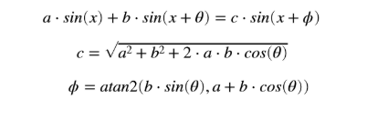

ϕ = a tan2 (b.sin(Θ), a+b.cos(Θ))

* A phase shift of 180° in the radial and axial direction (tolerance ±30°). (considering 2 sensors)

1. 22

* Once phase is determined and if it is 180° then publish the result through mqtt as General misalignment

1. 39

* Extraction of Instantaneous Frequency for Order Tracking in Rotating Machines Under Non-Stationary Operating Conditions

**Author:** O. Cardona-Morales, E.F. Sierra-Alonso and G. Castellanos-Dominguez

**Link:-** https://www.researchgate.net/publication/285989598_Blind_instantaneous_

rotational_speed_extraction_from_vibration_signals_of_rotating_machines_unde_non-stationary_operating_conditions

**Probabilistic identification of instantaneous rotational speed**

**Inputs: the vibration signal x(t) [Accelerometer data (Axial)] and the work interval [a, b]**

**1> Compute the spectrogram of x(t), noted as S(f,t).**

Let S(t,f) the spectrogram of a signal x(t) where (t,f) denotes time and frequency domains, respectively. The instantaneous frequency fmax(t) expressed in Hz, can be extracted by an algorithm of maxima tracking.

fmax(t) = arg max(S(t,f))

**2> Define an initial uniform partition for i = 0, Pi = {j*Delta_P + a|j=0,...,J-1} such that J=3, where Delta_P = (b-a)/(J-1) and J is Partition size.**

**3> Constrain the frequency domain of S(t,f) to [0, k*Delta_P+a]; for each j.**

**4> Extract an IF per Constrain frequency and scale it to the unity, obtaining omega_1(t).**

**5> Compute VSDFT using each omega_1(t) as referance shaft speed.**

**6> Compute IDFT per VSDFT obtaining the vibration signal in “pseudo-angular domain”.**

the signal in angular domain is obtained by the computation of inverse discrete Fourier transform (IDFT) from VSDFT.

**7> Obtain the pseudo-angle-order map per pseudo-angular domain value.**

An angle-order map A(alpha,ohm)is computed by means the spectrogram of x(alpha) with respect to ohm and it is assumed that this map is highly stationary, for which the probability distribution does not present considerable changes through the angle domain. It is worth noting that the map is highly stationary only if the waveform of extracted instantaneous frequency is close to the actual rotational speed.

**8> Compute the proposed stationarity measures Kurtosis, Cv(K|A(alpha,ohm)) or PCA method per j.**

**9> Select the extracted IF omega(t) with the minimum variability value as the most** c**losed to the rotational speed.**

**10> Rotational Speed is published to some topic through MQTT.**

**BEARING FAULT ANALYSIS**

Bearing is an indispensable element of almost any rotating machinery and as such bearings play a critical role in safe and reliable operation. Frequency of bearing failure is high in any machinery as compared to its other components and hence they are often responsible for the machine breakdown. In fact, the majority of the maintenance capital expenditure is spent on bearings. Bearing faults if detected at an early stage can prevent such failures and reduce downtime of equipment. In the last few decades many states of the art technology like vibration measurement, shock pulse method and acoustic emission techniques have been developed. This project focuses on vibration measurement technique and use of Fast Fourier Transformation (FFT) to obtain vibration amplitude versus frequency spectra for the study of bearing fault frequencies to detect and characterize different bearing faults. All vibration occurs at some frequency. Knowing the frequency of the vibration is paramount in diagnosing the problem. This is especially true for bearing. All roller bearings give off specific vibration frequencies, or tones, that are unique. A spectrum from FFT (Fast Fourier Transform) is an incredibly useful tool for machinery vibration analysis. If a machinery problem exists, FFT spectra provide information to help determine the source and cause of the problem. While the presence of certain defect frequencies in bearing spectrum confirms the presence of faults, the amplitude of these frequencies is an indication of bearing condition.

When a bearing spins, any defect or irregularities in the raceway surfaces or the rolling elements such as indentation, spalls, crack, flaking or irregularities in roundness of the rolling element excites periodic frequencies called fundamental defect frequencies. A machine with a defective bearing can generate at least five frequencies.

1. 41

These frequencies are:

1. Rotating unit frequency or speed (f): This is the frequency at which shaft on which bearing is mounted rotates. It is expressed in RPM, cycle per second (cps) or hertz (Hz)

2. Fundamental train frequency (FTF): It is the frequency of the cage. FTF seldom appears in vibration spectrums as the train hardly carries any load.

3. Ball pass frequency of the outer race (BPFO): It is the rate at which the ball/roller passes a defect in the outer race

4. Ball pass frequency of the inner race (BPFI): It is the rate at which a ball/roller passes a defect in the inner race. The level of BPFI is often slightly lower than BPFO as the vibration is generated further away from the transducer.

5. Two times ball spin frequency (2 X BSF): It is the circular frequency of each rolling element as it spins. When one or more of the balls or rollers have a defect such as a spall (i.e., a missing chip of material), the defect impacts both the inner and outer race each time one revolution of the rolling element is made. Therefore, the defect vibration frequency is visible at two times (2X) the BSF rather than at its fundamental (1X) frequency.

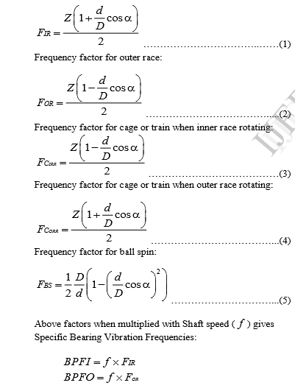

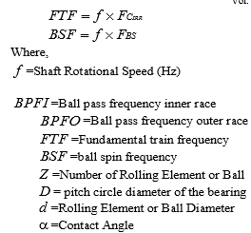

**BEARING STEPS**:

1. 40

First step is to install Vsens to the motor & next once Vsens is installed the next step is to configure vegam gateway to the vsens & vegam IOT platform

* The user information related to bearing details are taken from the Vmaint dashboard.
* Bearing details such as Number of balls/roller (NB), Pitch diameter (PD), ball diameter (BD) & contact angle are taken from user.
* Details are taken from the user and INPUT lookup table is formed & it is stored in mysql database.
* Calculate the bearing characteristics parameters from the given data using step 31 and save the results into another lookup table called bearing lookup table in database.

1. 42

* Reading FFT values of axial and radial axis from parser application according to the requirement for fault analysis.

1. 43

* All data will be in merged format, then we use some processing steps to clean the data and convert it to the required format.

1. 44

* next step is to find the Number of FFT windows for averaging.
* Number of FFT windows = number of samples/windowsize
* The details required for calculation are taken from sensor lookup table stored in mysql DB

1. 45

* calculating RMS for the FFT values.

1. 46

* The amplitudes which are greater than RMS values and corresponding frequencies are considered for further analysis

1. 47

* Next step is to select the frequencies corresponding to maximum amplitudes got in step 37.

1. 48

* Check whether these frequencies got in step 37 is similar to the bearing characteristics frequencies calculated in step 31.

1. 49 and 50

* If the range matches BPFI Frequency then we are checking for second harmonic and third harmonic for the same. If the harmonics are present then its strong evidence that its inner race fault in bearing.
* If the range matches BPF0 Frequency then we are checking for second harmonic and third harmonic for the same. If the harmonics are present then its strong evidence that its Outer race fault in bearing.
* If the range matches BSF Frequency then we are checking for second harmonic and third harmonic for the same. If the harmonics are present then its strong evidence that its Spin frequency fault in bearing.
* If the range matches FTF Frequency then we are checking for second harmonic and third harmonic for the same. If the harmonics are present then its strong evidence that its train frequency fault in bearing.

1. 51

* Publish these alert results back to vmaint through mqtt to some topic.

42 52

vmaint details

* Once these topics present in step 12, 20, 23,25,29 and 41 are subscribed in vmaint and alert results are published.